**Patient table**

|  |  |  |
| --- | --- | --- |
| **Attribute of table** | **Data Type** | **Special attribute** |
| Mobile Number | Number |  |
| Name | Varchar |  |
| Patient Id | Number | Primary Key |
| Address | Varchar |  |

**Medicine table**

|  |  |  |
| --- | --- | --- |
| **Attribute of table** | **Data Type** | **Special attribute** |
| Medicine ID | Number | Primary Key |
| Medicine Name | Varchar |  |
| Medicine Type | Varchar |  |
| Manufacturing brand | Varchar |  |

**Stock Table**

|  |  |  |
| --- | --- | --- |
| **Attribute of table** | **Data Type** | **Special attribute** |
| Shop id | Number | Foreign Key |
| Medicine ID | Number | Foreign Key |
| Quantity | Number |  |
| Expiry Date | Date |  |
| Stock ID | Number | Primary Key |

**Shop_detail table**

|  |  |  |
| --- | --- | --- |
| **Attribute of table** | **Data Type** | **Special attribute** |
| Shop id | Number | Primary Key |
| Shop Address | Varchar |  |
| Contact Number | Number |  |
| Stock ID | Number | Foreign Key |
| Medicine ID | Number | Foreign Key |

**Bill**

|  |  |  |
| --- | --- | --- |
| **Attribute of table** | **Data Type** | **Special attribute** |
| Bill_id | Number | Primary Key |
| Patient-id | Number | Foreign Key |
| Shop_id | Number | Foreign Key |
| Medicine ID | Number | Foreign Key |
| Amount | Number |  |

**Admin**

|  |  |  |
| --- | --- | --- |
| **Attribute of table** | **Data Type** | **Special attribute** |
| Employee | Number | Primary Key |
| Password | Varchar |  |
| Shop_id | Number | Foreign Key |

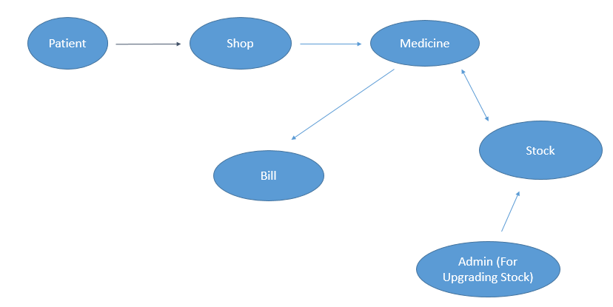

Functionality to be added – Buyer would be getting maximum discount applicable for him/her without any request.